**Dr Golly 2.0 - Developmental Milestones**

Track 0-5years

Creates a download to hand to Paediatrician

Example: [CDC app](https://www.cdc.gov/ncbddd/actearly/milestones-app.html)

**4 Categories for each age group:**

1. Social
2. Language
3. Cognitive
4. Movement

**3 Options for each milestone:**

1. Yes
2. Not Sure
3. Not yet

**Features:**

* Output that updates based on male/female
* Multiple seats to track multiple children

**WHEN TO ACT EARLY**

(this is available in the summary for all age groups)

1. Missing milestone

* Populates if you’ve said not sure or not yet

1. My baby has lost skills [he/she] once had

* Room to List

1. I am concerned my baby is not doing something I expect her to be doing

* Room to List

1. I have concerns about how my baby plays, learns, speaks, acts or moves

* Room to List

1. I have concerns about other things my baby does

* Room to List

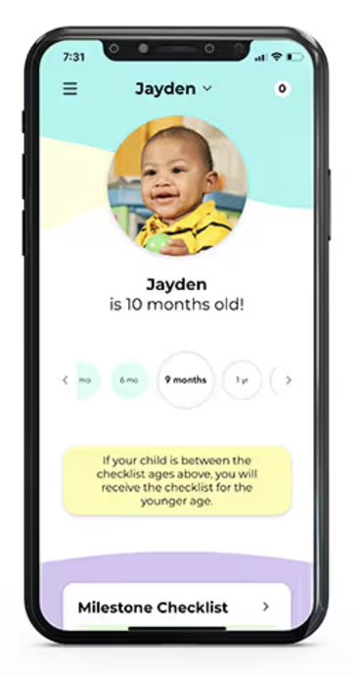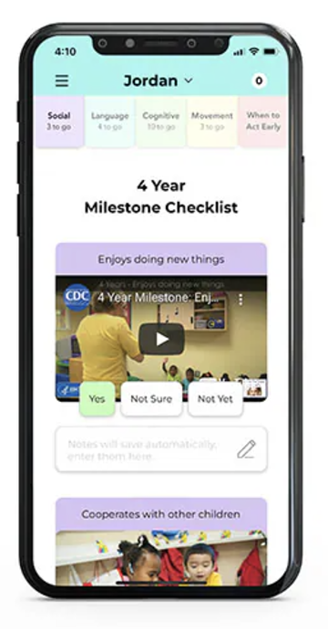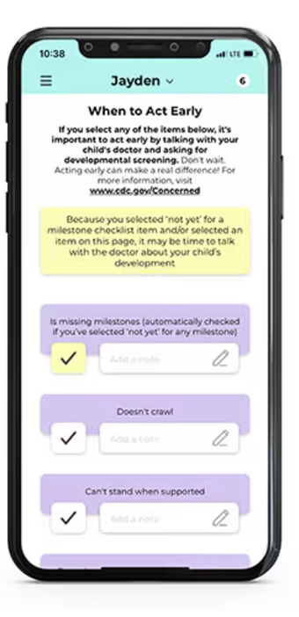

11 Milestone markers across 5 years

1. MILESTONES 0-4 Weeks
2. MILESTONES 2 MONTHS
3. MILESTONES 4 MONTHS
4. MILESTONES 6 months
5. MILESTONES 9 months
6. MILESTONES 1-2 year
7. MILESTONES 2 years
8. MILESTONES 30 months 2.5 years
9. MILESTONES 3 years
10. MILESTONES 4 years
11. MILESTONES 5 years

__________________________________________________________________________

**11 Milestone markers across 5 years**

#### 1.0 MILESTONES 0-4 Weeks

**Cognitive:**

Babies might briefly watch you/object

Recognise a parent’s voice and turn head towards the familiar sound

**Communication:**

Makes intentional communication sounds, like a coo

Will react to loud sounds

**Movement:**

Able to lift head when lying stomach-down

Move all 4 limbs

Open and clench hands

**Social:**

Responds to settling measures

Gaze at a face

Recognises familiar faces/sounds

Responsive smiling

#### 2.0 MILESTONES 2 MONTHS

**Cognitive:**

Watches you as you move (on their left or right side, but not yet able to track across their midline)

Looks at - and engages with - objects for several seconds

**Communication:**

Displays responsive coo sounds

Reacts to loud sounds

**Movement:**

Holds head up when on tummy

Moves all 4 limbs, improving head control

Opens hands intentionally

**Social:**

Calms down when soothed - increasingly responsive to parent

Looks at your face

Recognises and pleased by familiar faces/sounds

#### 3.0 MILESTONES 4 MONTHS

**Cognitive**:

Opens mouth if hungry and shown a breast or bottle

Watches and tracks you/object from one side to the other (across their midline)

Looks at [her/his] hands with interest

**Communication:**

Makes coo-ing sounds in a conversational manner (to/fro)

Makes sounds back when you talk to [him/her]

Turns head towards the sound of your voice

**Movement:**

Holds head steady without support when you are holding [him/her]

Holds a toy when you put it in [his/her] hand

Uses [his/her] arm to swing at toys

Brings hands to midline, up to mouth

Pushes up onto elbows/forearms when on tummy

Early signs of rolling

**Social:**

Smiles on [his/her] own to get your attention

Chuckles (not yet full laugh) to get your attention

Chuckles (not yet full laugh) when you try to make [her/him] laugh

Looks at you, moves, or makes sounds to get or keep your attention

#### 4.0 MILESTONES 6 months

**Cognitive:**

Puts things in [his/her] mouth to explore them

Reaches to grab a toy [he/she] wants

Closes lips to show [he/she] doesn’t want more food

**Communication:**

Takes turns making sounds with you

Blows ‘raspberries’ (sticks tongue out and blows)

Makes exploratory noises, plays with different breaths/sounds/squeals

**Movement:**

Rolls from tummy to back

Pushes up with straight arms from flat tummy position

Leans on hands to support [himself/herself] when sitting

Startle reflex begins to wane

**Social:**

Knows familiar people

Likes to look at [himself/herself] in a mirror

Laughs

#### 5.0 MILESTONES 9 months

**Cognitive:**

Looks for objects when covered or moved out of sight (like [his/her] spoon or toy)

Bangs two things together

**Communication:**

Makes different sounds like “mamamama” and “dadadada” (a parent might claim this as their first word!)

Lifts arms to be picked up

**Movement:**

Gets to a sitting position by themselves

Moves things from one hand to [his/her] other

Uses fingers to ‘rake’ food towards him/herself

Sits without support

**Social:**

Can be shy, clingy, or fearful around strangers

Shows several facial expressions like happy, sad, angry, and surprised

Looks when their name is called

Reacts when you leave (looks, reaches for you, or cries)

Smiles or laughs when you play peek-a-boo

#### 6.0 MILESTONES 1-2 year

**Cognitive:**

Able to put things in containers like a block in a cup

Looks for things when you hide them, such as a toy under a blanket

**Communication:**

Waves “bye-bye”

Calls parent “mama or dada” or another special name

Understands “no” and briefly pauses when [he/she] hears this

Has a mixture of babbling and real words. By 18 months learning 1-2 words per week or even 1 word a day.

**Movement:**

Uses pincher grip by picking things up between thumb and pointer finger, such as small pieces of food

Pulls up to a standing position

Walks holding on to furniture (cruising)

Able to drink from a cup without a lid (this might be while you hold the cup)

**Social**

Plays games like peek-a-boo with you

Engages in pretend play, such as pretending to drink from a cup, sweeping the floor

Enjoys spending time with other children

Knows and responds to their name

#### 7.0 MILESTONES 2 years

**Cognitive**

Holds something in one hand while using the other hand; for example, holding a container and taking the lid off

Tries to use switches, knobs, or buttons on a toy

Plays with more than one toy at the same time, like putting toy food on a toy plate

**Communication**

Points to things in a book when you ask, for example “where is the car?”

Says at least two words together, making a sentence, like “more milk”

Identifies and points to at least two body parts when you ask [him/her] to show you

Uses more gestures than just waving and pointing, like blowing a kiss or nodding yes

**Movement**

Kicks a ball

Runs

Walks (not climbs using hands) up a few stairs with or without help

Eats with a spoon

**Social**

Notices when others are hurt or upset, for example, pausing or looking sad when someone is crying

Looks at your face to see how you react in a new situation

#### 8.0 MILESTONES 30 months 2.5 years

**Cognitive**

Uses objects in pretend play, like feeding a block to a doll as if it were food

Demonstrates simple problem solving skills, like standing on a small stool to reach something

Follows two-step instructions like “put the toy down and close the door”

Shows they know at least one colour, like pointing to a blue crayon when asked “which one is blue?”

**Communication**

Says approximately 50 words

Says two or more words together, with one action word, like “bird fly”

Able to name objects in a book when you point and ask “what is this?”

Says words like “I”, “me” or “we”

**Movement**

Uses hands to twist things, like turning door knobs or unscrewing lids

Takes some clothes off [him/herself], like loose pants or an open jacket

Jumps off the ground with both feet

Turns book pages one at a time, when you’re reading to them

**Social**

Plays next to other children and sometimes plays with them

Shows you what [he/she] can do by saying “look at me!”

Follows simple routines when told, like helping to pick up toys when you say “it’s clean up time.”

#### 9.0 MILESTONES 3 years

**Cognitive**

Draws a circle when you show them how

Avoids touching hot objects like a stovetop when you warn [him/her] not to

Able to listen to instructions

**Communication**

Talks to you in conversation with back and forth exchanges

Asks who, what, where, when and why questions

Says what is happening in a book when asked like “running”, “eating” or “playing”

Says first name when asked

Talks well enough for others to understand most of the time

**Movement**

String items together, like large beads or penne pasta

Puts on some clothes by themself like loose pants or jacket

Uses a fork

**Social**

Calms down within 10 mins after you leave him/her in a safe environment, like at childcare drop off

Notices other children and joins them to play

#### 10.0 MILESTONES 4 years

**Cognitive**

Names a few colours of items

Anticipates and verbalises what comes next in a well-known story

Draws person with 3 or more body parts

**Communication**

Says sentences with four or more words

Says some words from a song, story or nursery rhyme

Talks about at least one thing that happened during [his/her] day, like “I played in the sandpit”

Answers simple questions like “what is a hat for?” or “what is a pencil for?”

**Movement**

Catches a large ball most of the time

Serves [herself/himself] food or pours water, with adult supervision

Unbuttons some buttons

Holds crayon or pencil between fingers and thumb (not a fist)

**Social**

Pretends to be something else during play (teacher, superhero, dog)

Asks to go play with children if none are around, like “can I go play with Jack today?”

Comforts others who are hurt or sad, like hugging a crying friend

Avoids danger, like not jumping from tall heights at the playground

Likes to be a “helper”

Alters behaviour based on where [he/she] is (library, beach, playground, kinder)

#### 11.0 MILESTONES 5 years

**Cognitive:**

Counts to 10

Names some numbers between 1 and 5 when you point to them

Uses words about time like “yesterday,” “tomorrow”, “morning” or “night”

Pays attention for 5-10 minutes during activities e.g. during story time or making arts and crafts (screen time does not count)

Able to write some letters in [his/her] name

Names some letters when you point to them

**Communication**

Tells a story [she/he] heard or made up with at least two events. e.g. I walked to the playground with Grandma, we saw a dog on the way

Answers simple questions about a book or a story after you read or tell it to [him/her]

Keeps a conversation going with more than three back and forth exchanges

Uses or recognises simple rhymes (bat-cat, ball-tall)

**Movement**

Able to fasten some buttons

Hops on one foot

**Social**

Follows rules and can take turns when playing a game with other children

Sings, dances or acts for you

Does simple chores at home, like matching socks or unpacking the dishwasher